**What exactly *is* the AP Human Geography Course?**

“*This course introduces students to the systematic study of patterns and processes that have shaped human understanding, use, and alteration of Earth’s surface. Students employ spatial concepts and landscape analysis to examine socio economic organization and its environmental consequences. They also learn about the methods and tools geographers use in their research and applications. The curriculum reflects the goals of the National Geography Standards.*

*The goal of the course is for students to become more geo-literate, more engaged in contemporary global issues, and more informed about multicultural viewpoints. They develop skills in approaching problems geographically, using maps and geospatial technologies, thinking crucially about texts and graphic images, interpreting cultural landscapes, and applying geographic concepts such as scale, region, diffusion, interdependence, and spatial interaction, among others.*

*Students will see geography as a discipline relevant to the world in which they live; as a source of ideas for identifying, clarifying, and solving problems at various scales; and as a key component of building global citizenship and environmental stewardship*. In a nutshell: *AP Human Geography is a course equivalent to an introductory college-level course in human geography*.”

**Why take an AP course at all?!**

Because it is AWESOME! *“The AP program enables willing and academically prepared students to pursue college-level studies-what the opportunity to earn college credit, advanced placement, or both-while still in high school. Through AP courses skills are gained to prepare students for college and beyond. Taking AP courses demonstrates to college admission officers that students have sought the most challenging curriculum available to them. Most four-year colleges and universities in the United States grant credit, advanced placement, or both on the basis of successful AP exam scores. More than 3,300 institutions worldwide annually receive AP scores*.”

**What are the course skills to the class?**

“*There are five ‘course skills’ students will grasp throughout the study of our class. These are central to the study and practice of human geography. You will have the opportunity to develop and apply the described skills on a regular basis over the span of the course. The skills are as follows [*next few pages, 2-6 {skills images acquired from summer AP training program}*]*:”

**\*AP College Board\***

**Is there summer homework?**

Yes! The rationale behind this is to not act as a vetting process by any means. This summer work opportunity allows students to begin the school year with a bit more in our back pockets which allow forging ahead with content sooner. Therefore, over summer, students and parent(s)/guardian(s) will understand the operations of the class. This also assists students in becoming familiar with content while working through several tasks that will become familiar in the 2023-2024 school year. While the homework will not fully grasp the course guidelines, expectations, and rigor, summer homework is a good place to begin. *See pages 7-9 for the tasks requiring completion over summer break.*

Skill Category (SC) 1: Concepts and Processes

*Analyze geographic theories, approaches, concepts, processes, or models in theoretical and applied contexts.*

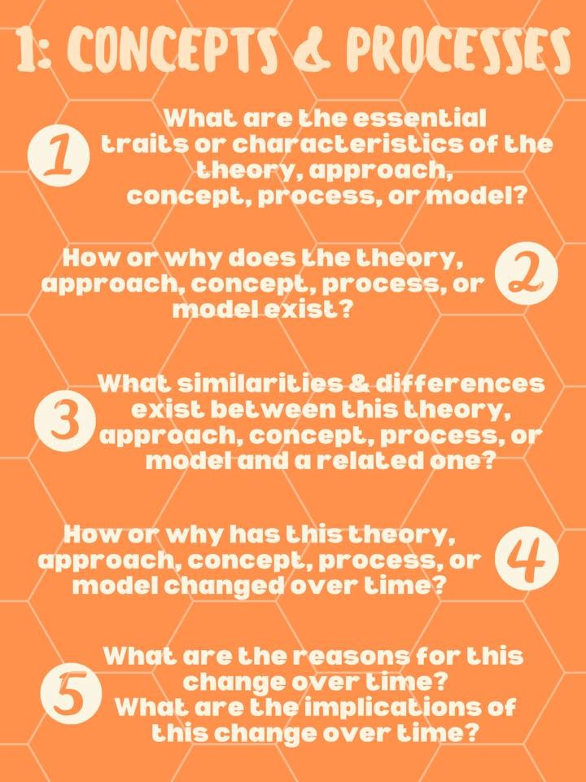

SC2: Spatial Relationships

*Analyze geographic patterns, relationships, and outcomes in applied contexts.*

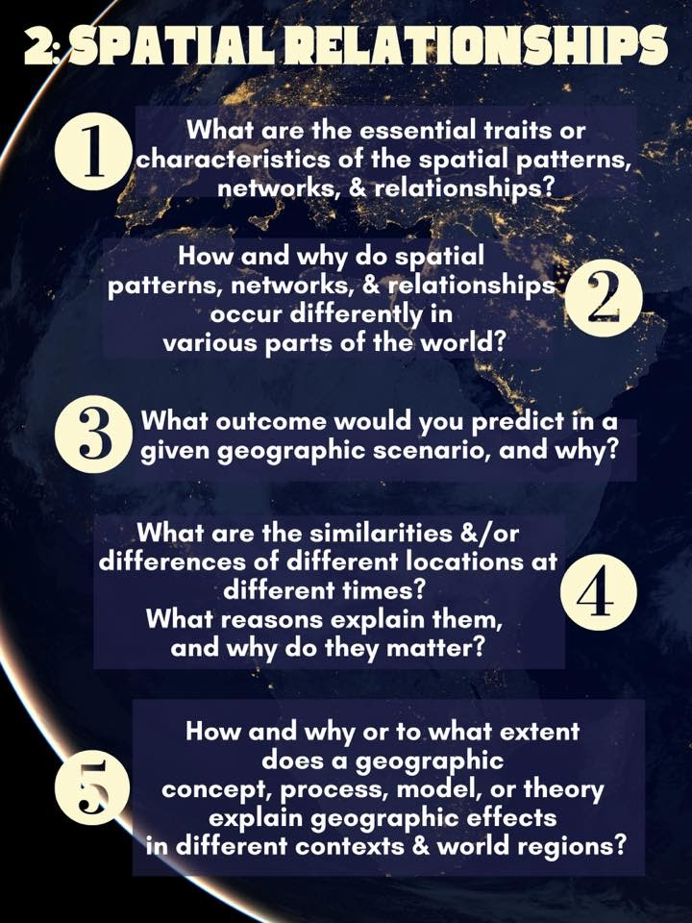

SC3: Data Analysis

*Analyze and interpret quantitative geographic data represented in maps, tables, charts, graphs, satellite images, and infographics*

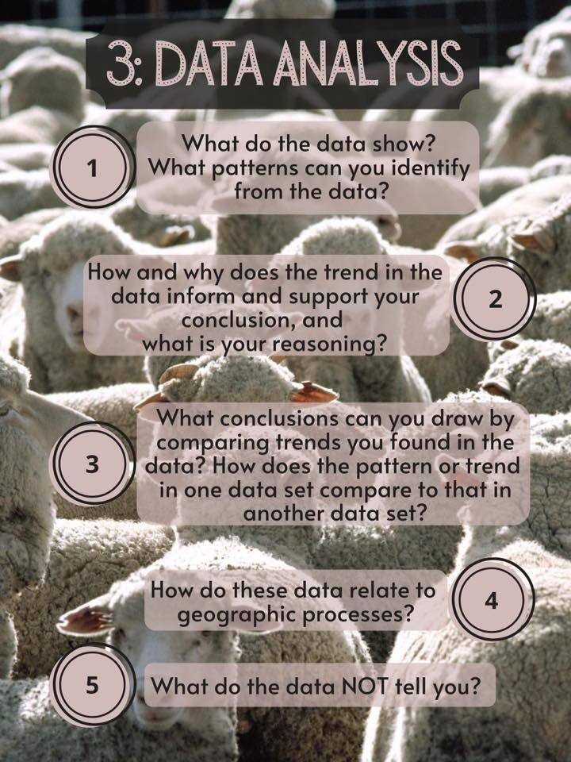

SC4: Source Analysis

*Analyze and interpret qualitative geographic information represented in maps, images (such as satellite, photographs, cartoons, etc…), and landscapes.*

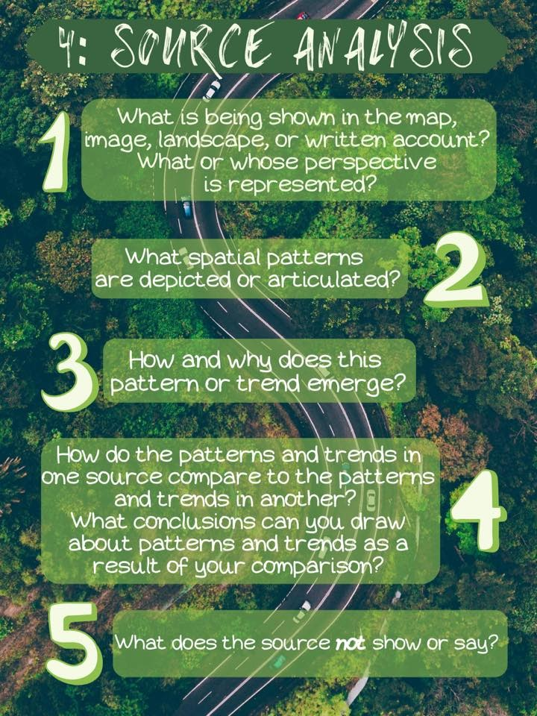

SC5: Scale Analysis

*Analyze geographic theories, approaches concepts, processes, and models across geographic scales to explain spatial relationships.*

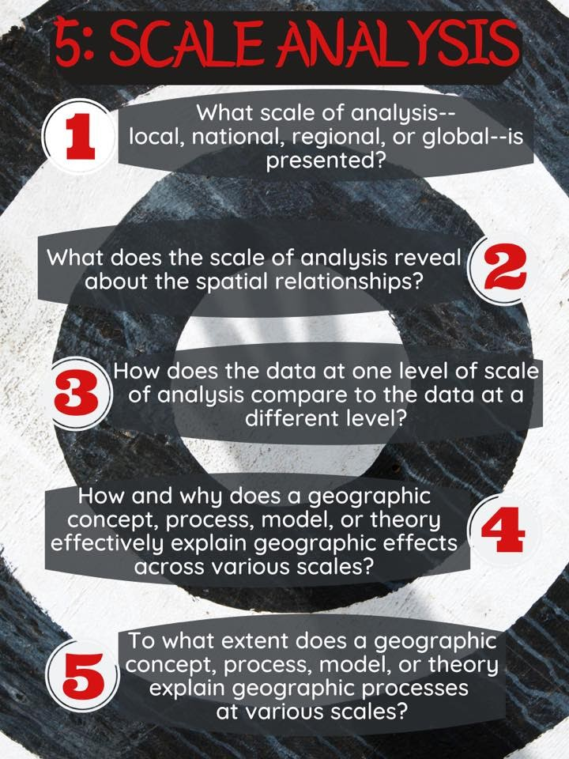

*Summer Tasks Requiring Completion Prior to the First Day of School*

**Task #1 of 3**

**“Scavenger Hunt”**

*Objective:*

Find answers to the questions provided by going on a ‘scavenger hunt.’ In order to BEST prepare you for what you are about to embark on, in terms of what to expect on the final exam (*what the entire course caters too*), utilize online resources that are reputable to correctly reflect your responses.

*How to Answer AND Submit:*

Students are to create a word document titled, ‘APHG_Task 1 Summer Work’ and email me your responses prior to the first day of school to: [lgustafson@helenaschools.org](mailto:lgustafson@helenaschools.org)

*NOTE:*

Not everyone takes the final national exam held at The Delta Hotel. I do greatly recommend registering and taking the test though. With that said, ALL students, regardless if you register or not, WILL take a final exam on the same day, just within our own classroom. The entire course revolves around preparing for this final exam, therefore, no one is exempt from taking this end of course test. Therefore, the expectation is that all students, regardless of registration status, answer the questions below.

*Questions:*

1. When is the test date for our AP Human Geography National Exam [which is the same date for in-class testers]?

2. How much does the test cost if I were to register for the National Exam?

3. When do I have to register for the national exam?

4. How is the AP Human Geography test structured (i.e., how many parts and of what)?

5. How long is the test, total?

6. How is the exam weighted?

7. What role does vocabulary play on the test?

8. How is the test scored?

9. How do I interpret the scores?

10. How many units are tested on the final exam (i.e., how many units do students learn about throughout the course)? AND list the titles of each unit.

*Summer Tasks Requiring Completion Prior to the First Day of School*

**Task #2 of 3**

**“Current Event”**

*What is a current event?*

“Current events are any type of new worthy event that is communicated to the public through written or spoken words which has a political, economic, religious, social, and/or health impact on our planet.”

*Objective:*

As a class, students will be exploring events which are happening every-day and on a weekly basis report findings. These events can and do directly affect our lives. The ability to know HOW events are affecting the lives of humans and our planet are pivotal to connecting with content and understanding the need for exploring our coursework.

*Task:*

Your task is to research and find TWO current events that occur over the summer break. Each separate current event needs to directly link to TWO of the units AP Human Geography covers..

*Remember, you found the units of study in the scavenger hunt so please reference ‘Task #1 of 3.’*

Step 1: Open a Word Doc and appropriately title it, ‘APHG_Task 2 Summer Work’

Step 2: Research current events throughout the summer (“*what is happening now*”) using news sources that are reputable (‘*have a good reputation*’), select and identify TWO.

Step 3: Summarize each article in no less than five sentences, reminding yourselves to quote text taken directly from the article. This summary is your own words.

Step 4: Offer an opinion on each article. This simply means grapple with what you just read; ask yourself questions about the article you want to know more about, offer an explanation behind why you chose the topic you did, supply inquiry-based questions that alert me to your thoughts, etc.

Step 5: Indicate for each current event, which unit your article relates best too and explain why (*remember, you have seven to choose from*). Keep in mind, I am aware you have not learned this material yet. Based on the unit topic though, how does each article relate to the unit you have linked it to?

Step 6: Copy and paste the articles link so I am able to see where you obtained your current event. *Hyperlinking preferred*.

Step 7: Send your completed task (steps 1-7 got TWO current events) to my email prior to the first day of school to: [lgustafson@helenaschools.org](mailto:lgustafson@helenaschools.org)

*Summer Tasks Requiring Completion Prior to the First Day of School*

**Task #3 of 3**

**“Personal Reflection”**

*Objective:*

Reflect on your decision to choose AP and inform you instructor about the choice to take this college entry-level course at HHS.

*Task:*

Answer the following questions in a word doc, appropriately titled, ‘APHG_Task 3 Summer Work’ and submit to my email upon completion, prior to the first day of school to: [lgustafson@helenaschools.org](mailto:lgustafson@helenaschools.org)

*Reflection Questions:*

1. I am excited you have chosen to take AP. I am curious as to what led you to enroll in this advanced placement course as a freshman.

2. How do you balance school, homework, and after school activities in a positive and meaningful way? OR intend too upon starting high school? (*I.e., what strategies do you employ to assist in managing the rigor of an AP course with your day to day?*)

3. What are you most excited about learning in our AP Human Geography course and/or exploring?

4. Have you had other siblings, family members, friends, and/or acquaintances take this or any other AP classes at HHS or elsewhere? *If so, where, what do you know, and what AP classes?*

5. What questions about AP in general do you have?