Bengal Happenings

[Bell Schedules](https://hsd1-my.sharepoint.com/:w:/g/personal/bkessler1_helenaschools_org/EU9IYr_kQvtBl-OnWU6S58IBxIJFqmCf4hHq8NEIipK2ig?e=QzF2dg)

Follow us – Facebook (Helena High School) and Instagram (helenahighschoolbengals)

**Homecoming Week!**

After the first full week of the 2024-2025 school year ends, we hope everyone enjoys the reprieve from the hot summer weather this weekend! This coming week brings a great deal of excitement and engagement opportunities at school. We hope everyone is able to take part in as much as possible! To help keep everything straight, we hope to highlight the big items below:

One of the best parts of Homecoming Week is the spirit week dress up days. After students voted on Mama Mia! as the theme for the dance, our Student Council has worked diligently to build that theme into as many aspects as possible for the week. Their creativity has allowed them to utilize some of the best ABBA songs and aspects of the movie into the dress up days for the week. We want to remind and encourage everyone to participate at the level they can with the days. Our Bengal Closet has great clothing articles available that can be accessed if someone needs something to help complete their outfit each day.

*Monday -* “Lei all your love on me” - An epic game of rock, paper, scissors will commence on Monday, with everyone given a lei at the start of the day. Leis can be won if you beat another person with a lei during passing periods.

*Tuesday* – Our Last Summer – wear beach inspired clothing. A reminder that clothing needs to be school appropriate – everyone needs to wear shirts, pants, and shoes to school.

*Wednesday* – Super Trooper Trios – find a couple of friends and dress alike!

*Thursday* – Denim Donna Day – Wear Jeans!

*Friday* - “Dancing Queen” Class Color Day – Seniors wear white, Juniors blue, Sophomores pink, Freshmen purple.

Other events happening this week:

*Monday* – Senior Parent Night – 5:30 p.m. in the Little Theater

*Tuesday* – Open House Block Party – Come join us for a great night of seeing what HHS has to offer your children! Soccer hosts Sentinel at 3 and 5 p.m.

*Thursday* – Volleyball hosts Sentinel with the Freshmen and Sophomore games starting at 4:00 p.m.

*Friday* – Football vs Glacier at 7 p.m.

*Saturday* – Homecoming Dance from 8-11 p.m. at HHS

**Attendance Support**

With the start of the new year and new secretaries in the attendance office, we appreciate your patience as we adjust to these positions and how we have it staffed. We are making a few adjustments this coming week with the hopes that it streamlines our processes and abilities to work with families for attendance purposes. We do ask that you review the reminders below:

* When calling to excuse your child for the day or to get them out for an appointment and need to leave a message, please make sure you include and spell their last name in the message.
* If you are calling to excuse your child for an appointment, please excuse them for the time they need to leave in order to get to their appointment on time.
* If you know your child has an appointment coming up, you are welcome to call before the day of the appointment to excuse them.
* If your child has a recurring appointment, we are happy to work with you on a plan for that, so you do not need to call in each day to excuse them.
* All students need to sign out and sign back in if they are leaving for an appointment. If you are picking up for an appointment, the best place to do so is the drop off loop on the north side of the building. Students need to stop by the attendance office by the cafeteria to sign out.

**NAMI Walk**

Mental Health Awareness and Support is something we take seriously at Helena High. One annual event that we encourage participation in each year is the NAMI (National Alliance on Mental Illness) Walk. This year, the walk and vendor fair will take place on Sunday, September 22 at 12:30 p.m. Warm up and a chance to visit the vendors at the event will start at 11:30 a.m.

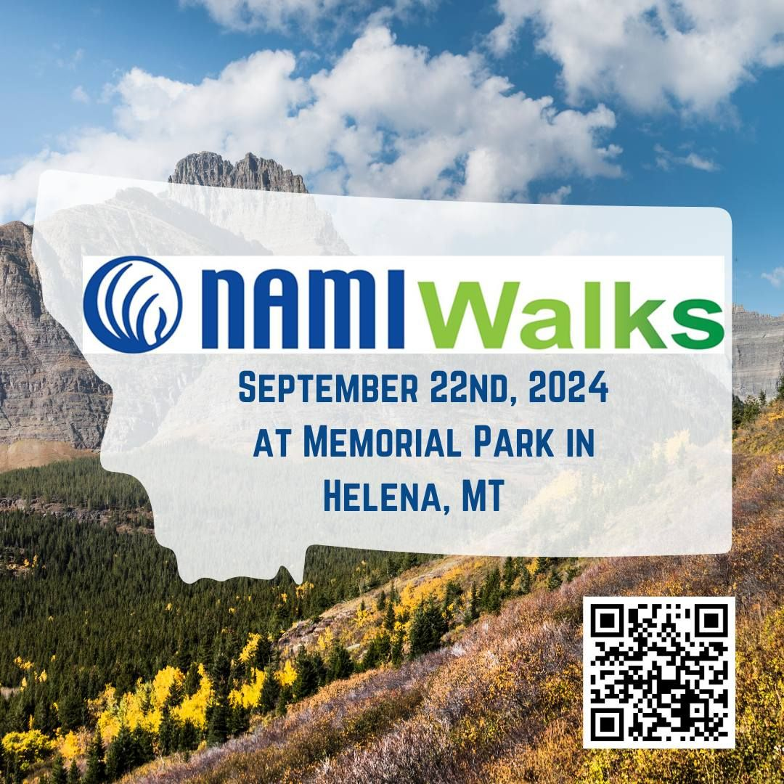

**Booster Club Support Opportunities**

We are lucky to have an active Booster Club working to support all clubs and activities in our building. They are unable to do this, though, without the support of our amazing families and donors. Two fundraisers are coming up over the next month to get on your calendars:

*Buffalo Wild Wings Night* – September 30 – Bring in the coupon below and a portion of your tab will be donated back to HHS Boosters.

*Dueling Pianos Event –* October 12 – more info to come on how to purchase a seat or table for friends and family. This will be a crosstown event, and we look forward to beating the Bruins in this event this year as well!

**Native American Students Open House Invitation**

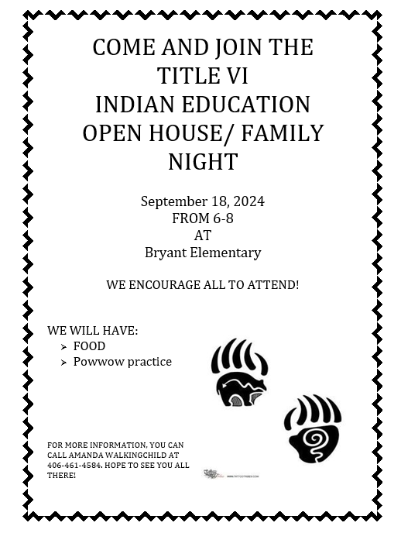

**Counseling Center Communication**

* Dual Credit registration is complete! If your student missed this event, please contact Cheryl Ravenscroft at Helena College at 406 447-6993.
* The last day to change schedules was 9/13/24. Any requests must now go through administration.
* Senior Parent Night is 9/16/24 at 5:30 PM in the Little Theater.
* FSA ID Night- 11/13/24 This will kick start our FAFSA application process.

**AP Exam Registration** is now open through November 15th for students enrolled in an AP course. Taking an AP exam is an opportunity for your student to earn college credits or advanced placement. AP exams are optional, but strongly encouraged. The exam fee of $50 can be paid online at [**https://helenaschools.revtrak.net/**](https://helenaschools.revtrak.net/)**.** Additional fee waivers are available if your student qualifies for free/reduced lunch.

After the November 15th registration deadline, a $40 late fee will be added to each exam registration. Exams cannot be ordered after March 15th. Exams cancelled after Nov. 15th are subject to a $40 cancellation fee withheld from the refund. Learn more about the AP exam opportunity, policies, and dates by referencing the AP Exam Registration email sent out to families on September 9th. If you have any AP related questions, or did not receive the email, please contact Ellaina Staldine at [estaldine@helenaschools.org](mailto:estaldine@helenaschools.org).

**Angel Fund Applications-** Angel Fund is a generous program designed to help families purchase basic school clothing, shoes, and warm outerwear. Students who qualify for free/reduced lunch and demonstrate satisfactory attendance can apply for Angel Fund assistance to receive $200 to shop at designated local stores. Applications are available starting on **October 1st- November 30th**. If interested, please send your student to the counseling office to pick up an application on or after October 1st.

**Upcoming Dates –** [**Complete Year at a Glance**](https://hsd1-my.sharepoint.com/:w:/g/personal/bkessler1_helenaschools_org/ERNxHCZ0EwdGu0FwviVS8KUBsZ7JPgj2c2eU5YsdCm5TAg?e=kROyda) **(This document will be updated as dates are changed)**

September 2024

16 – Senior Parent Night 5:30 pm Little Theater

16-20 – Homecoming Week!

17 – Open House/Block Party – 5:30-7:30 p.m.

20 – Homecoming/Fall Pep Assembly – Assembly Schedule

21 – Homecoming Dance 8:00-11:00 p.m. HHS Gym

27 – Juniors to Pow Wow Demonstration Day – 9:30-11:30 a.m.

30-Oct 4 – College Application Week

***From Last Week***

**What’s Going on in Class?**

We look forward to finding an effective, streamlined way to communicate with you regularly on what is happening in our classes. We ask that you bear with us as we fine-tune our formatting for these messages but hope that the information provided helps you get a glimpse of what your child is learning in class and what major assignments, projects, and units are coming up for the month. Each department has been tasked with providing information to answer the following three questions:

1. What are the major units/topics that will be covered the next four weeks?
2. What major assignments, projects, or tests are coming up in the next four weeks?
3. How can families interact with their child about the content being covered?

We have split the departments into two separate groups to share this information. The group below will always be sharing information during the first week of the month, with the rest of our departments sharing out the third week. As mentioned in previous communications, all teachers will also be updating their weekly agendas on their teacher webpages. This week, we check in on the following departments:

[***English***](https://hsd1-my.sharepoint.com/:w:/g/personal/bkessler1_helenaschools_org/EXKskahXIlJPnUkTm5kDpcUBUsLiC_e2dVxAA4rvsIYt1A?e=YFJdvB)

[***Math***](https://hsd1-my.sharepoint.com/:w:/g/personal/bkessler1_helenaschools_org/ESrXAyqhiYRHjX4ICPChF-MBFS2TZI2AT1ZF5T_elRKcxg?e=GqICgx)

[***Social Studies***](https://hsd1-my.sharepoint.com/:w:/g/personal/bkessler1_helenaschools_org/EXQuNgywiJtCraWgsFuEC_wBbNCGamNtpLixvd3JJDSZ-g?e=OaBSfi)

[***Science***](https://hsd1-my.sharepoint.com/:w:/g/personal/bkessler1_helenaschools_org/ERh7u9z95KVAu68GO3HzLz0BXe_QvMT2QVD4a4aJpavrEg?e=M7SKh7)

[***Phyiscal Education***](https://hsd1-my.sharepoint.com/:w:/g/personal/bkessler1_helenaschools_org/EauzTYdj_h1BmxbOrbvP3s8BAFuwrEGXrPQzjHU3uKNU9g?e=0QQ4zN)

**Nurse Information**

With school starting comes the emergence of colds and illnesses. The graphic below is a helpful reminder from our Nurse on how we can help limit the spread of viruses.

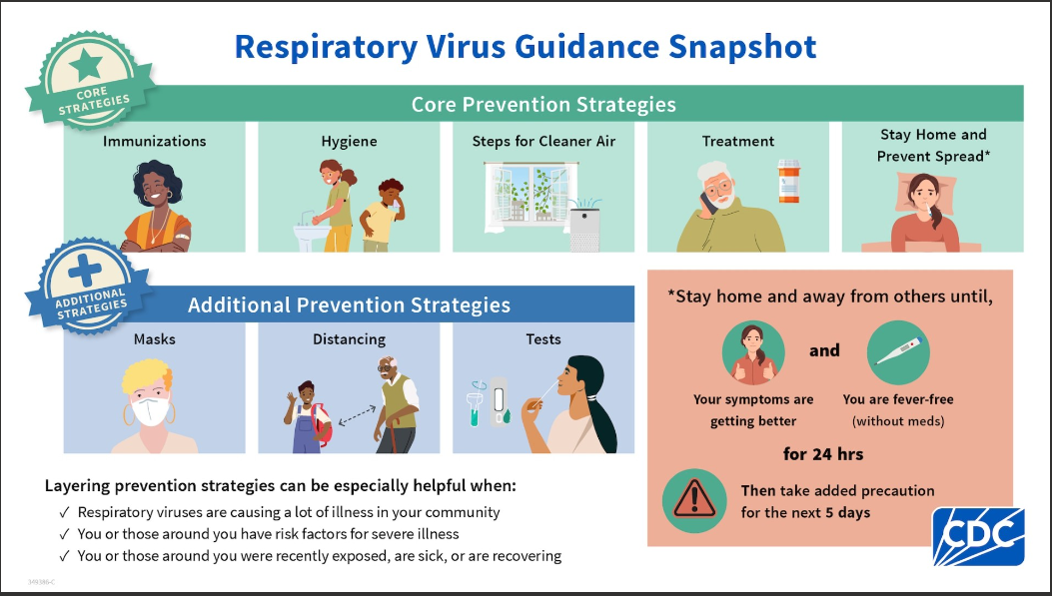

**Would You Like to Substitute? Para Subs?**

We are incredibly thankful for the great individuals we have who substitute teach throughout the district every day. We are always, though, looking for more people to help fill the open positions we have each day throughout the district and are hoping you may consider completing the application online to join our substitute pool. In addition to teaching assignments, we can always use help in our paraprofessional pool, a position that can be equally rewarding in that you get an opportunity to work with some of our most incredible students! To sign up to be a sub, follow this link: <https://www.applitrack.com/helena/onlineapp/default.aspx?Category=Substitute>

**Open House Invitation**

We are switching things up a little bit for our Open House this year. Instead of having you follow your child’s schedule to meet their teachers and hear more about their classes, we are going to go with more of an Open House Block Party theme this year. Here is the plan -

* Starting at 5:30 p.m. on Tuesday, September 17, we will have food trucks, games, booths, and music from our amazingly talented students set up and ready for you to enjoy in the parking lot on the east side of the gym. Families are encouraged to bring their children to the event as we will also have our NHS, Link Crew, and Student Council students available to help keep younger students engaged while you get a chance to connect with our teachers.
* From 6:00-7:00 p.m. the school will be open for families to meet their child’s teachers, tour the school if you would like, and get a glimpse of the great things our students and staff are doing day in and day out. During this time, the booths, games, and music will continue outside.
* From 7:00-7:30, we will wrap up the evening with a Pep Rally, as it is also Homecoming Week, to highlight our fall sports teams, cheer, and dance squads, and finish off with a rousing rendition of the Bengal Fight Song!

We hope you can join us for this event – it will be an exciting time!

**Digger Days Opportunity**

Over the summer, members of the CTE departments at both Capital and Helena High School worked to create an opportunity for students to explore construction jobs and interact with members of those industries. The Digger Days is open to all students at HHS and CHS at a cost of $10 – scholarships are available if needed. Please see the poster below and use the QR code to sign up if interested. Those wishing for more information can contact Mr. Jake Spearson ([jspearson@helenaschools.org](mailto:jspearson@helenaschools.org)).

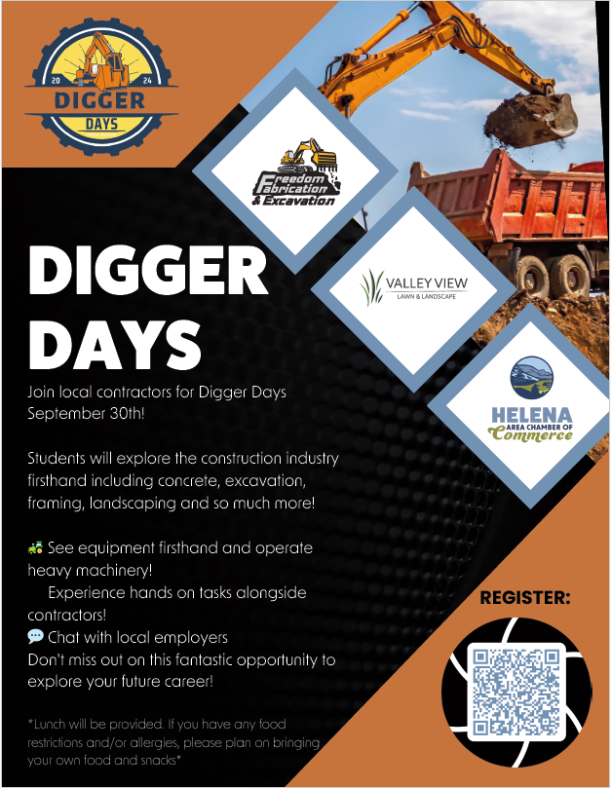

**Free and Reduced Lunch Forms and Submission**

If you need assistance in paying for your child’s meal costs, please make sure you apply for the Free and Reduced Lunch program. Even if you are unsure if your family will qualify for the program or not, we highly encourage you to submit the application as there are a variety of factors that can allow a family to receive the support. The application is confidential and helps to ensure that students have access to food if needed.

The online application can be accessed here: <https://dca.opi.mt.gov/FRAPP?SponsorNum=0487>

You can find out more about the program and the benefits associated with it by visiting the [Food Service website](https://helenaschools.org/departments/food-services/).

**Counseling Center Info from Last Week**

* Dual Credit Registration will be September 10th and 11th. Check with your student about their paperwork or access it [here](https://hhs.helenaschools.org/counseling-and-career-guidance/dual-credit-forms-information/).
* The last day for schedule changes is September 12th.
* Save the Date! Senior Parent Night 9/16/24 at 5:30 PM in the Little Theater.
* College Career Fair at Carroll College on 9/23/24 from 1:30 – 3:30. [Register for a chance to win a scholarship!](https://www.montanacolleges.com/)
* FSA ID Night

**From the Main Office Last Week**

**Angel Fund Applications and Resources**

We are once again appreciative for the support the Helena Community provides in supporting the Angel Fund organization, allowing us the opportunity to have school supplies available for those in need and to continue the clothing program available to those that qualify. If your child needs support with getting needed school supplies, please have them contact their counselor, and we will help them get what they may need. We will again have locations around the school with extra notebooks, pencils, pens, and highlighters that anyone can take if they need something for a class.

If you believe you are eligible for support in utilizing the Angel Fund for school clothing, please contact Mrs. Ellaina Staldine at [estaldine@helenaschools.org](mailto:estaldine@helenaschools.org) to obtain the application and work through the approval process to be able to get set up for clothing to be purchased.

**Senior Picture Submission**

All information pertaining to the submission of Senior Photos for the Yearbook can be found on the [HHS Yearbook Webpage](https://hhs.helenaschools.org/about/yearbook/). Senior photos must be submitted, in proper format and sizing, to Ms. Walsh by October 31. You can also purchase a yearbook from the site linked on our Yearbook page.