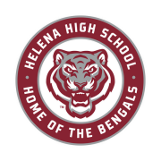
THANK YOU SPONSORS!

HELENA HIGH SCHOOL BOOSTER CLUB

DIAMOND SPONSORS

4Js Casino
Loose Caboose Casino
Helena Orthodontics
Laird Cowley, PLLC
Prickly Pear Pediatric Dentistry
Slate Architecture

SILVER SPONSORS

Big Sky Plumbing and Heating
Capital Collision Center
First Interstate Bank
Heuiser Physical Therapy
Mountain Materials and Construction

CARDINAL SPONSORS

Advocate Physical Therapy
Blue Cross Blue Shield of Montana
Bob Denherder, EXIT Realty
Mt. Ascension Physical Therapy Group
TruGreen
Opportunity Bank
Placer Subaru

